**Configure-request**

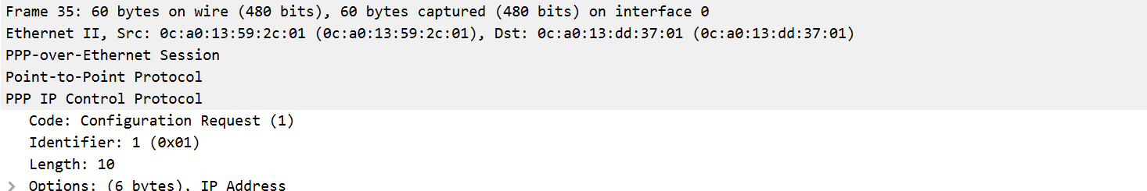

**Configure-ack**

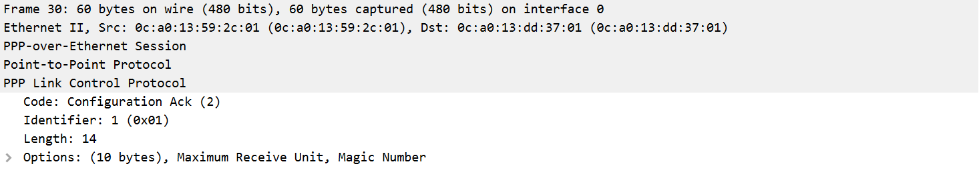

**Configure-nak**

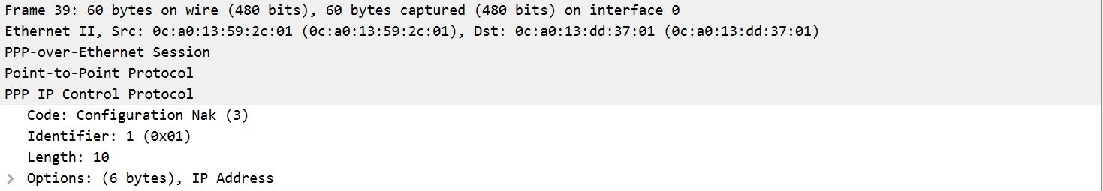

**Terminate-request**

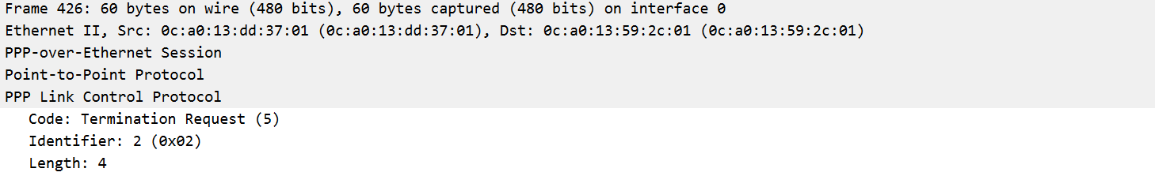

**Protocol-reject**

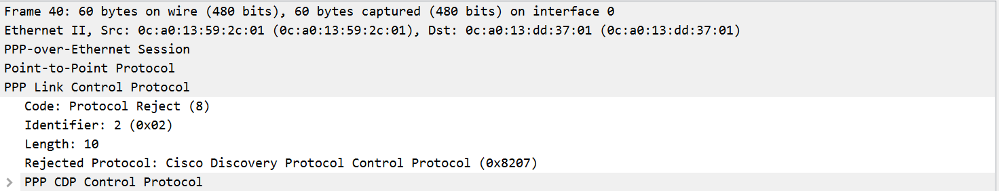

**Echo-request**

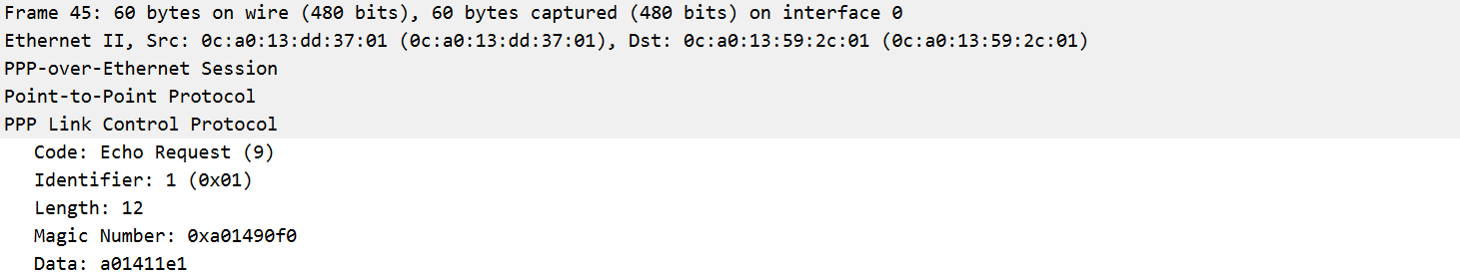

**Echo-reply**

